**DRIVES, CONTROLLING AND MODELLING LAB**

**Experiment I:**

**Introduction to Matlab**

**Aim:**

i. To understand various simulation environments in Matlab.

ii. To develop the models for DC excited first order RL Circuit in various simulation environments.

iii. To develop RLC network in circuit approach in Matalab/Simulink

**Matlab:**

**• MATLAB stands for MATrix LABoratory.**

• **It is a software package for high-performance numerical computation and visualization.**

• **It provides an interactive environment with hundreds of built-in functions for technical computation, graphical and animation.**

**Problem1:**

**Matlab Matrix operations:** creation of matrix, inv, det, complex matrix, string matrices, etc.

**Mathematical operations:** Solving general expressions and mathematical functions.

**Graphics:** plot instructions

**Matlab Script:** m file and editor.

**Functions:** creation and operation of functions.

**Laplace transform operations:** create transfer functions, step function etc

**Simulink:** various general Simulink block sets, **simscape**

**SOLUTION:**

**Command-line matrix functions**

* **Row Matrix**

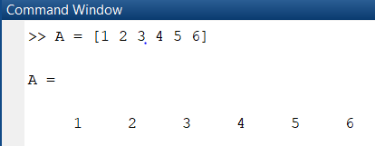

* **Column Matrix**

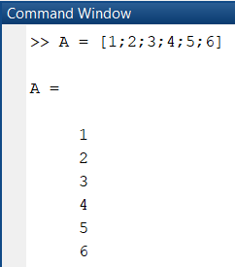

* **3x3 Matrix**

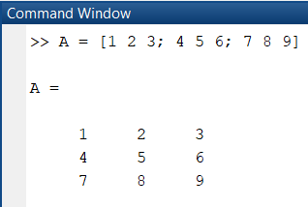

* **Matrix Inverse**

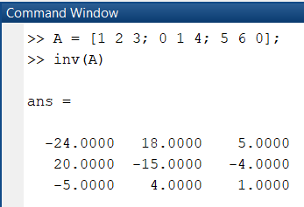

* **Matrix Determinant**

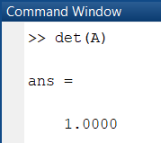

* **Matrix Rank**

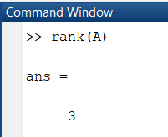

* **Matrix Size**

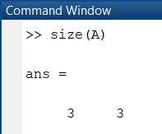

* **Matrix Transpose**

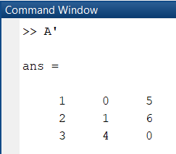

**Sample Graphs**

* **Rose plot**

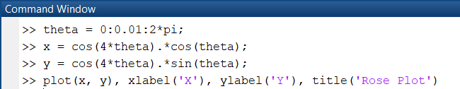

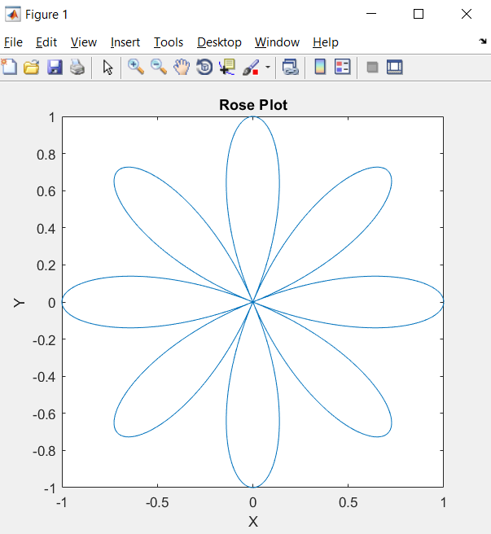

**Problem2:**

Develop the solution for current in series RL circuit in following domains of Matlab.

i) Using direct expression for current in script.

ii) Using transfer function approach in script.

iii) Using Simulink block diagram approach mathematical & transfer function.

iv) Using Simulink simscape.

**SOLUTION:**

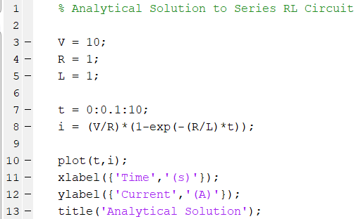

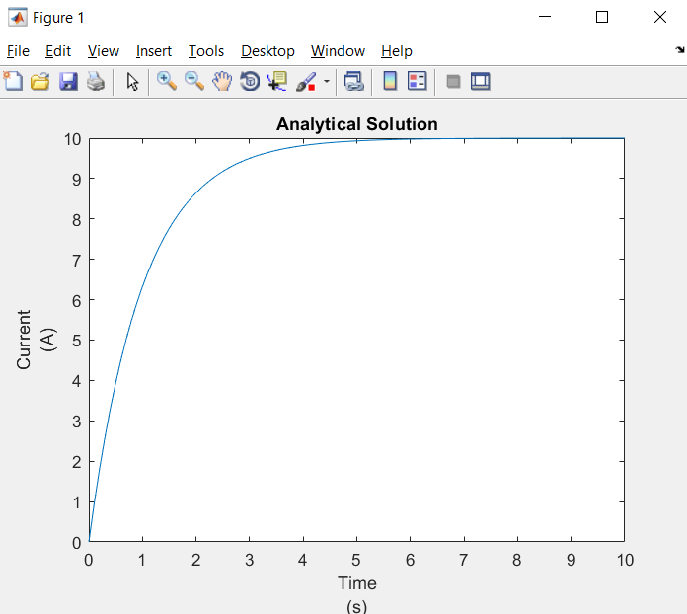

**ii)**

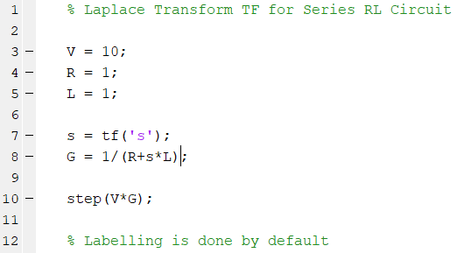

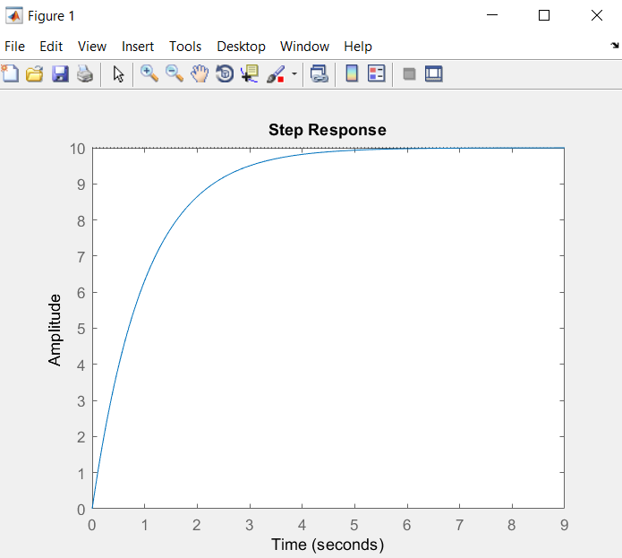

**iii)**

1. **Mathematical Approach**

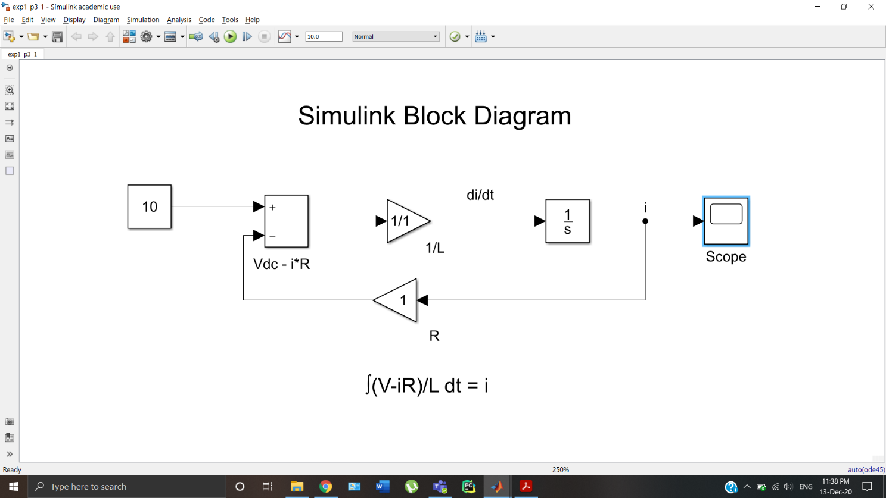

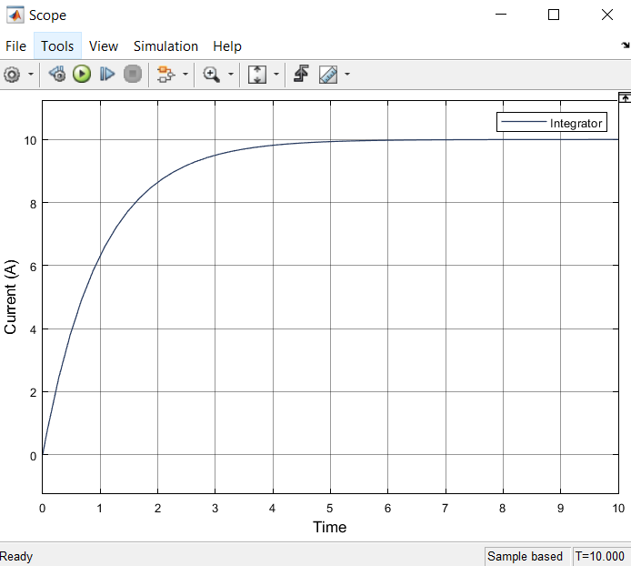

1. **TF Approach**

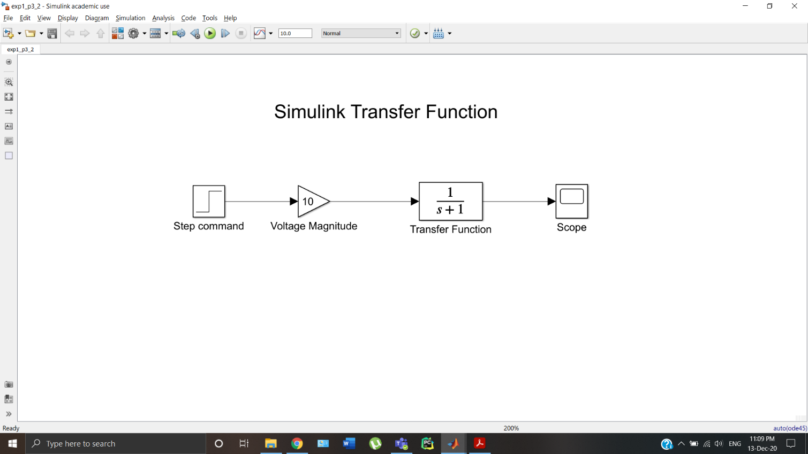

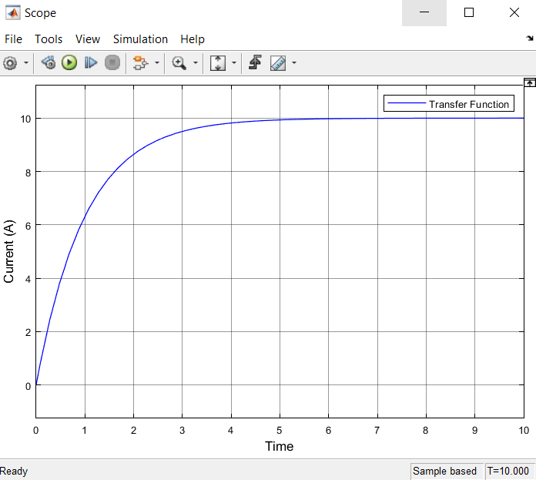

**iv)**

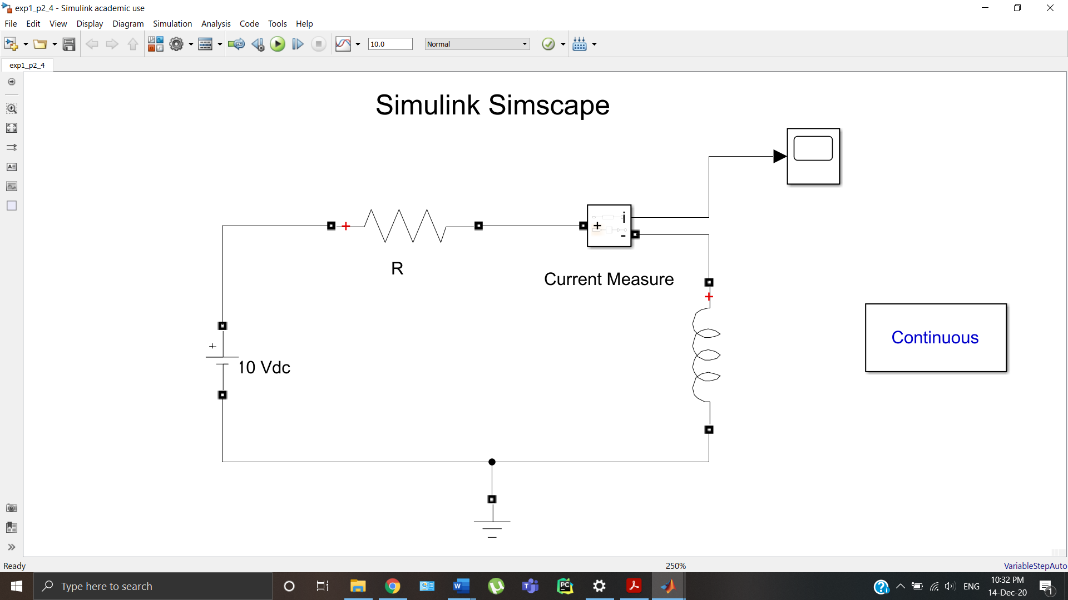

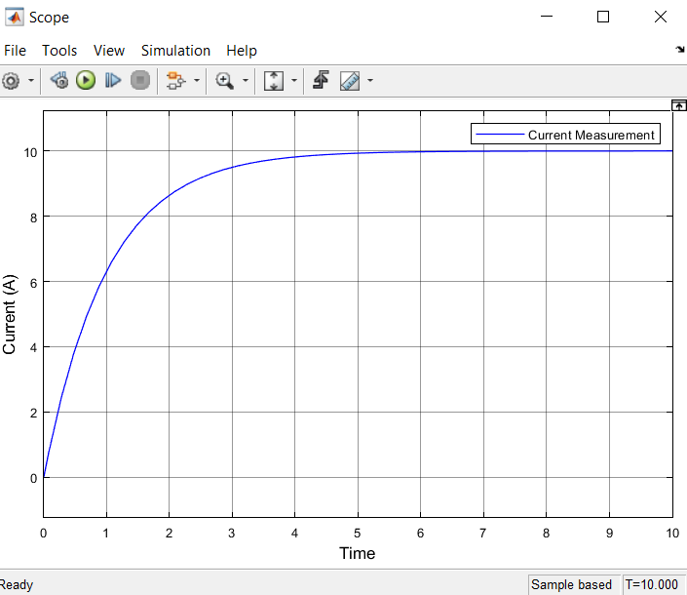

**Problem3:**

Develop the solution for voltage in series RLC circuit in Matlab.

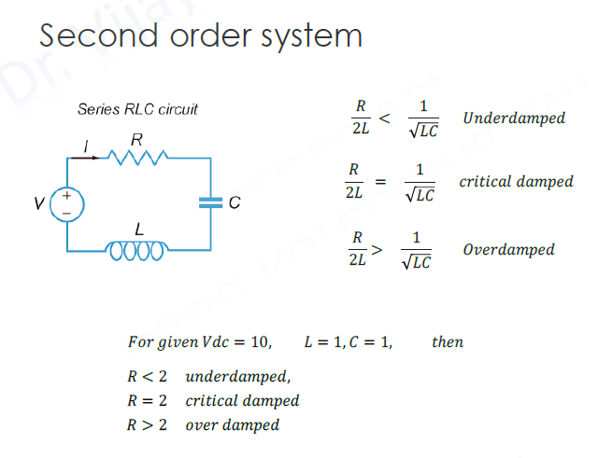

**SOLUTION:**

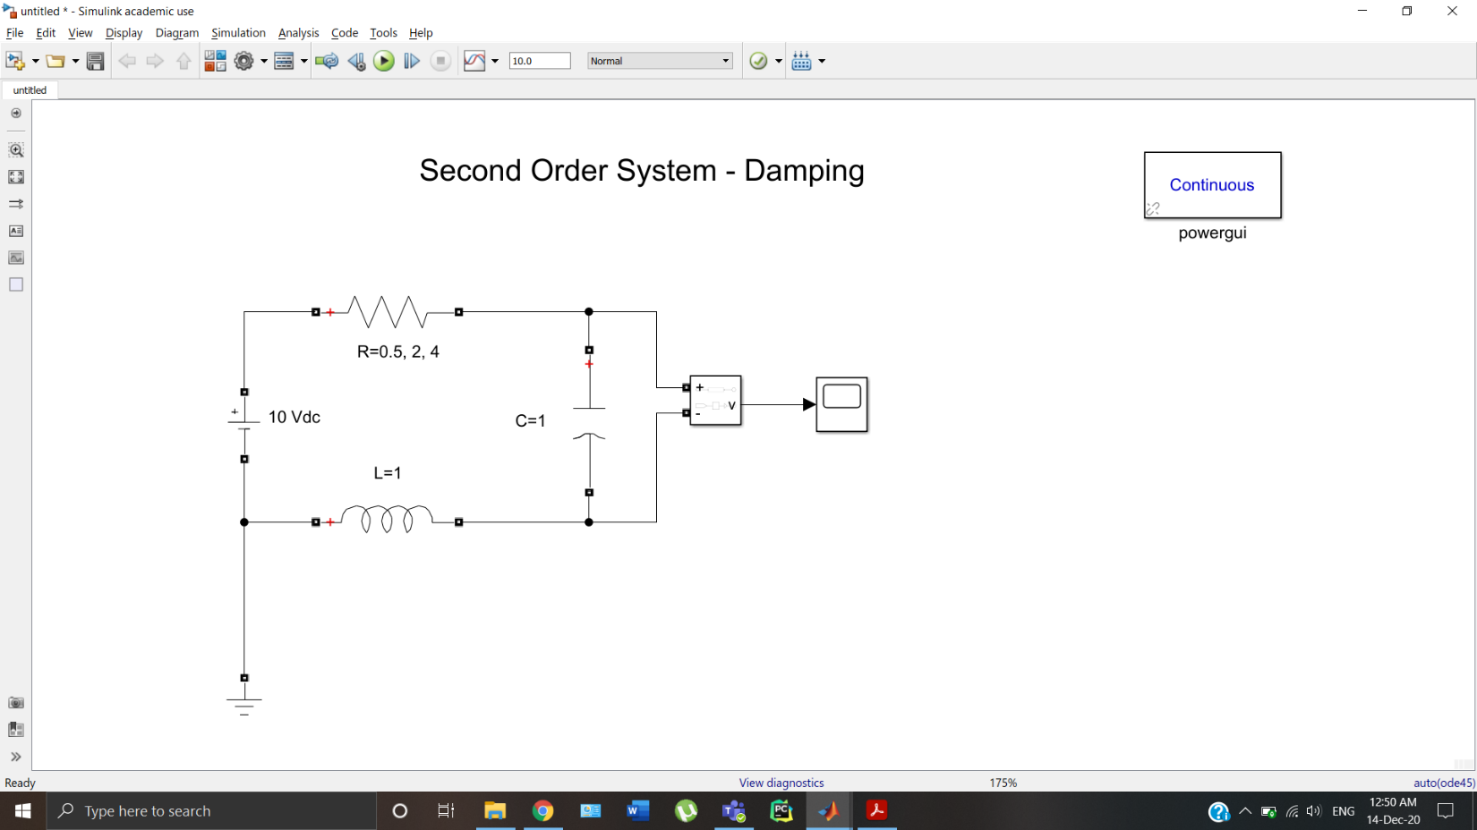

1. **Underdamped (R=0.5Ω)**

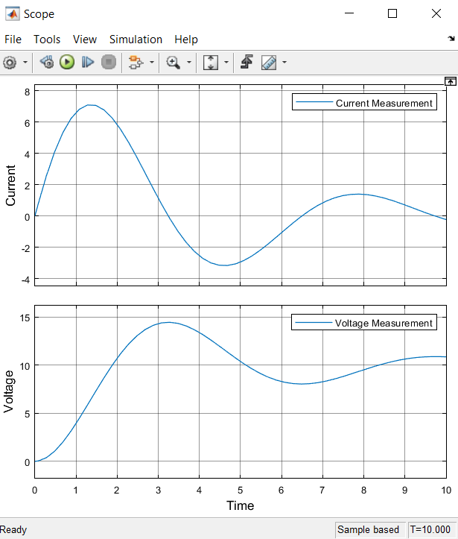

1. **Critically Damped (R=2Ω)**

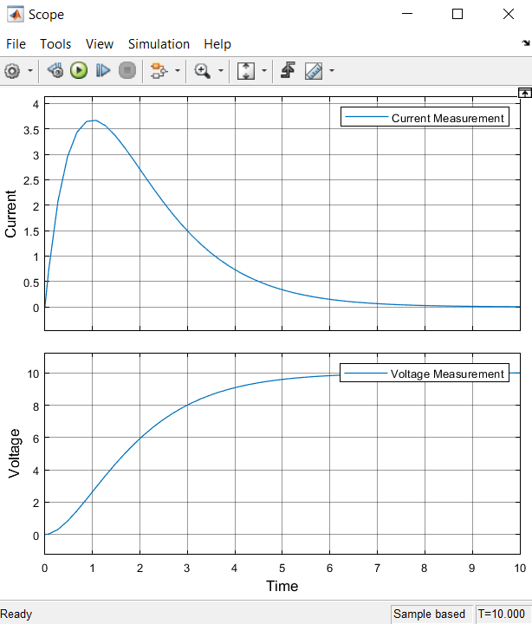

1. **Overdamped (R=4Ω)**

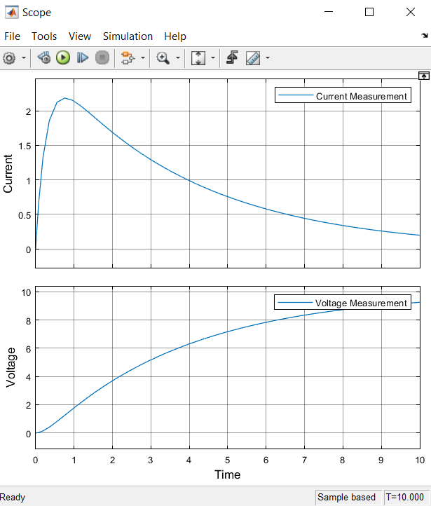

**Experiment II:**

**Open loop Simulation of Buck and Boost Converters**

**Aim:**

To simulate the open loop Buck and Boost, (DC-DC voltage converter) using **Simscape**

**Problem 1:**

Understand the concept switched mode power conversion.

**SOLUTION:**

1. **Voltage Divider**

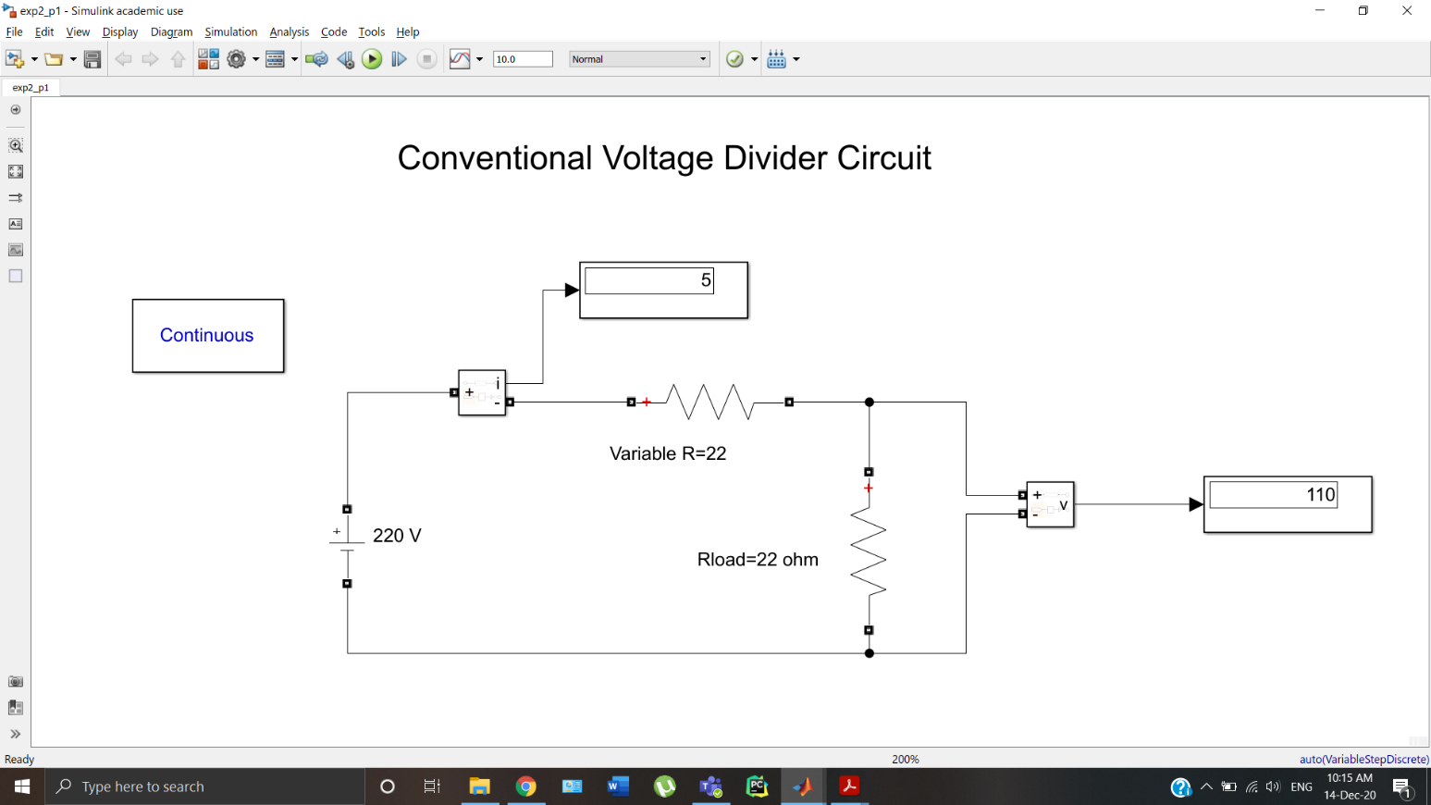

1. **DC-DC Switched Converter**

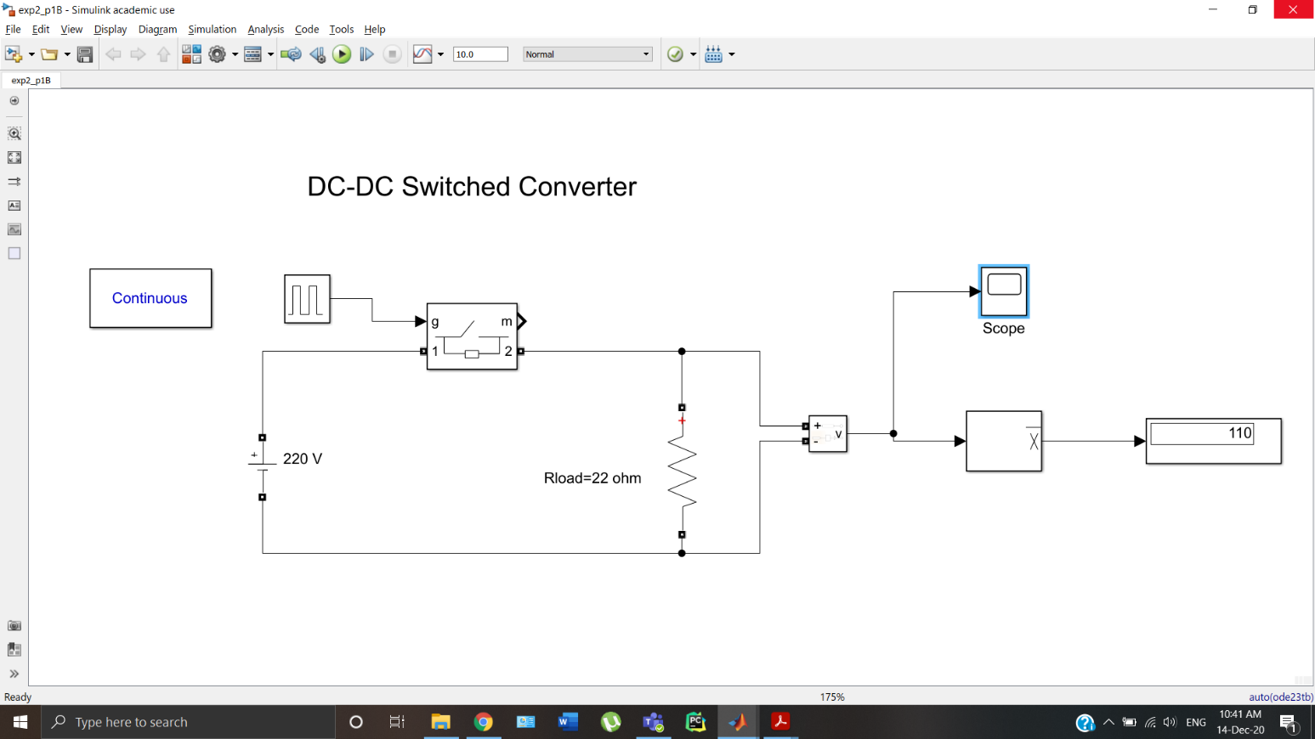

**d = 50%**

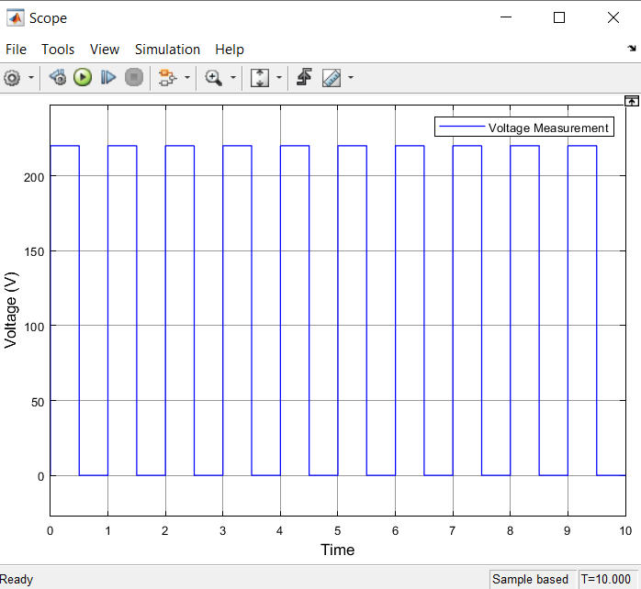

**Problem 2:**

Plot the voltage response of a Buck converter across a resistive load of 22 ohm. The source voltage is 220 V and PWM signal has 50% duty cycle and 0.1ms period. Also plot the current in the circuit. Model the circuit with ideal switching devices and L = 100 ×10-3 H, C = 100 ×10-6 F. Understand the significance of efficiency improvement using switched mode power conversion.

**SOLUTION:**

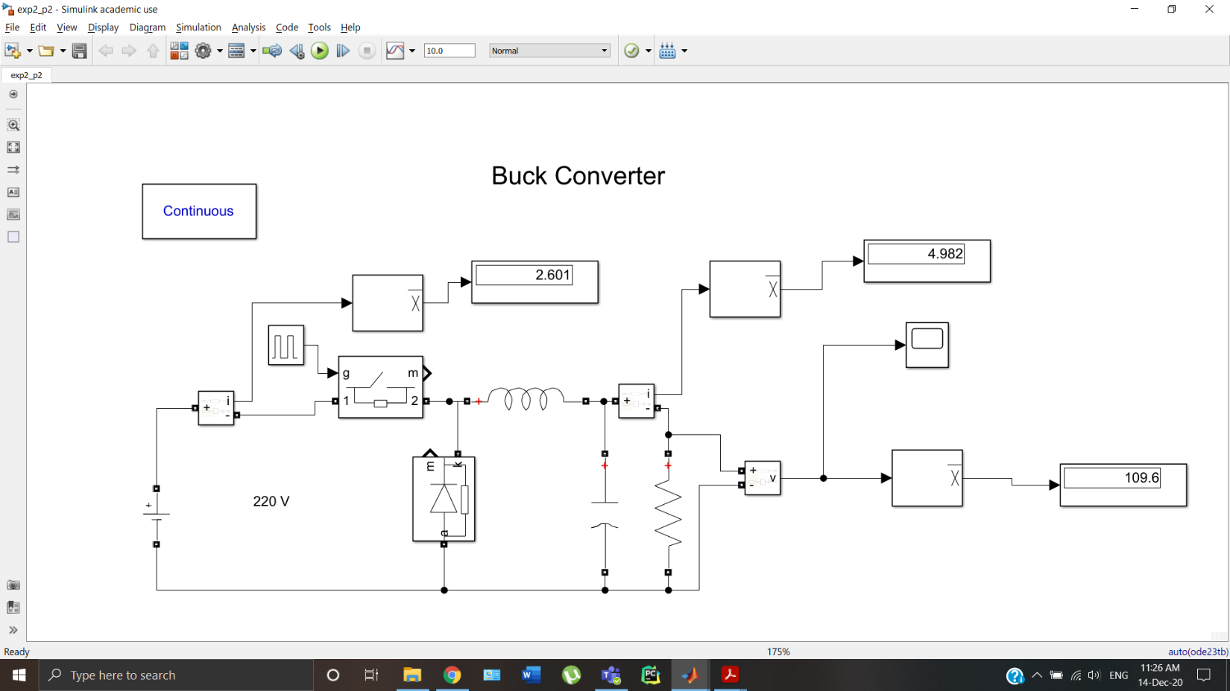

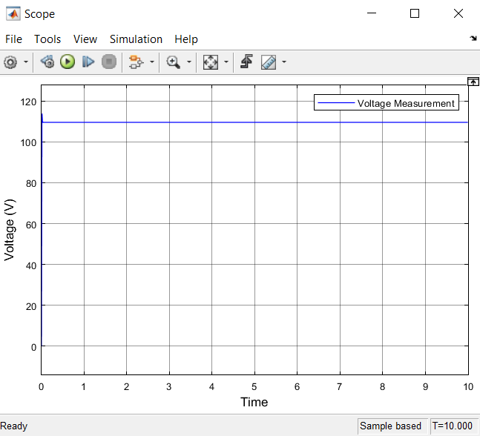

**Problem 3:**

Plot the voltage response of a Boost converter across a resistive load of 22 ohm. The source voltage is 220 V and PWM signal has 50% duty cycle and 0.1ms period. Also plot the current in the circuit. Model the circuit with ideal switching devices and L = 100 ×10-3 H, C = 100 ×10-6 F.

**SOLUTION:**

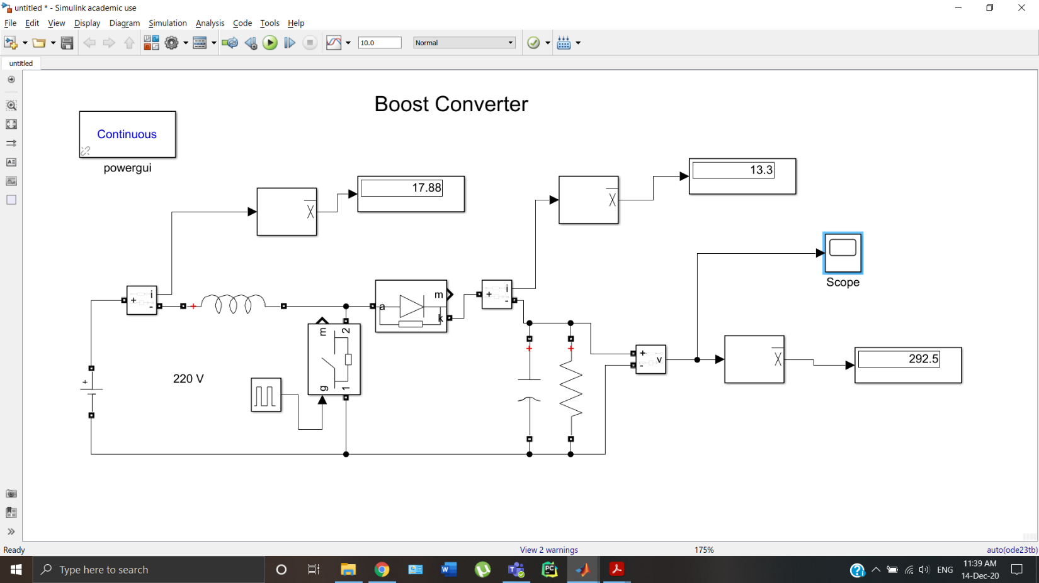

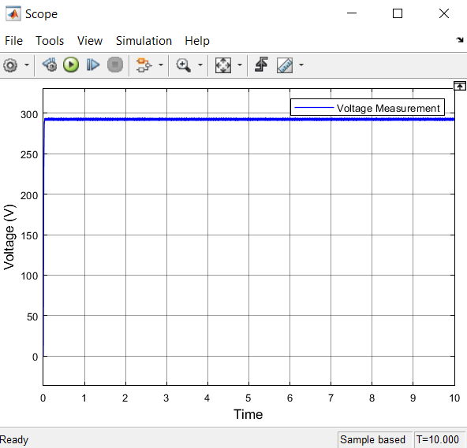

**Experiment III:**

**Closed loop Simulation of Buck and Boost Converters**

**Aim:**

To simulate the closed loop Buck and Boost, (DC-DC voltage converter) using **Simscape**

**Problem 1:**

Plot the voltage response of a closed loop Buck converter across a resistive load of 22 ohm. The source voltage is 220 V and PWM duty cycle is generated using PID controller block. Model the circuit with ideal switching devices and L = 100 ×10-3 H, C = 100 ×10-6 F and switching frequency 10KHz. Understand the significance of closed operation with fixed and step change in reference points.

**SOLUTION:**

1. **Fixed Reference**

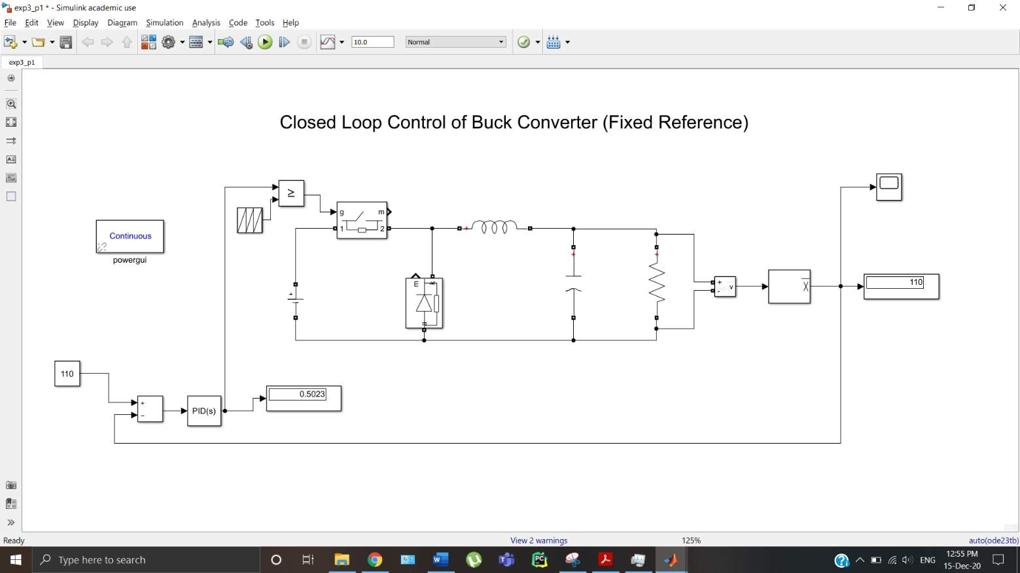

**kp=0.01, ki=0.08, kd=0**

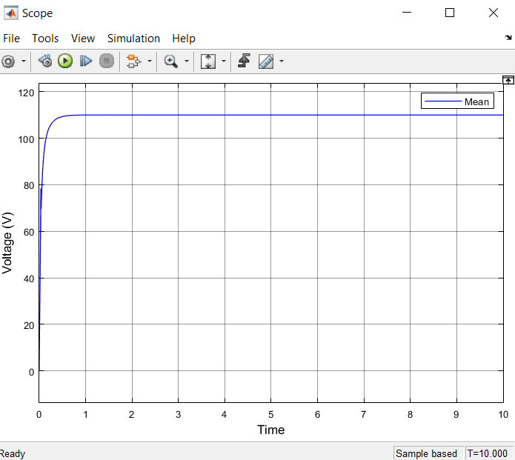

1. **Step Change in Reference**

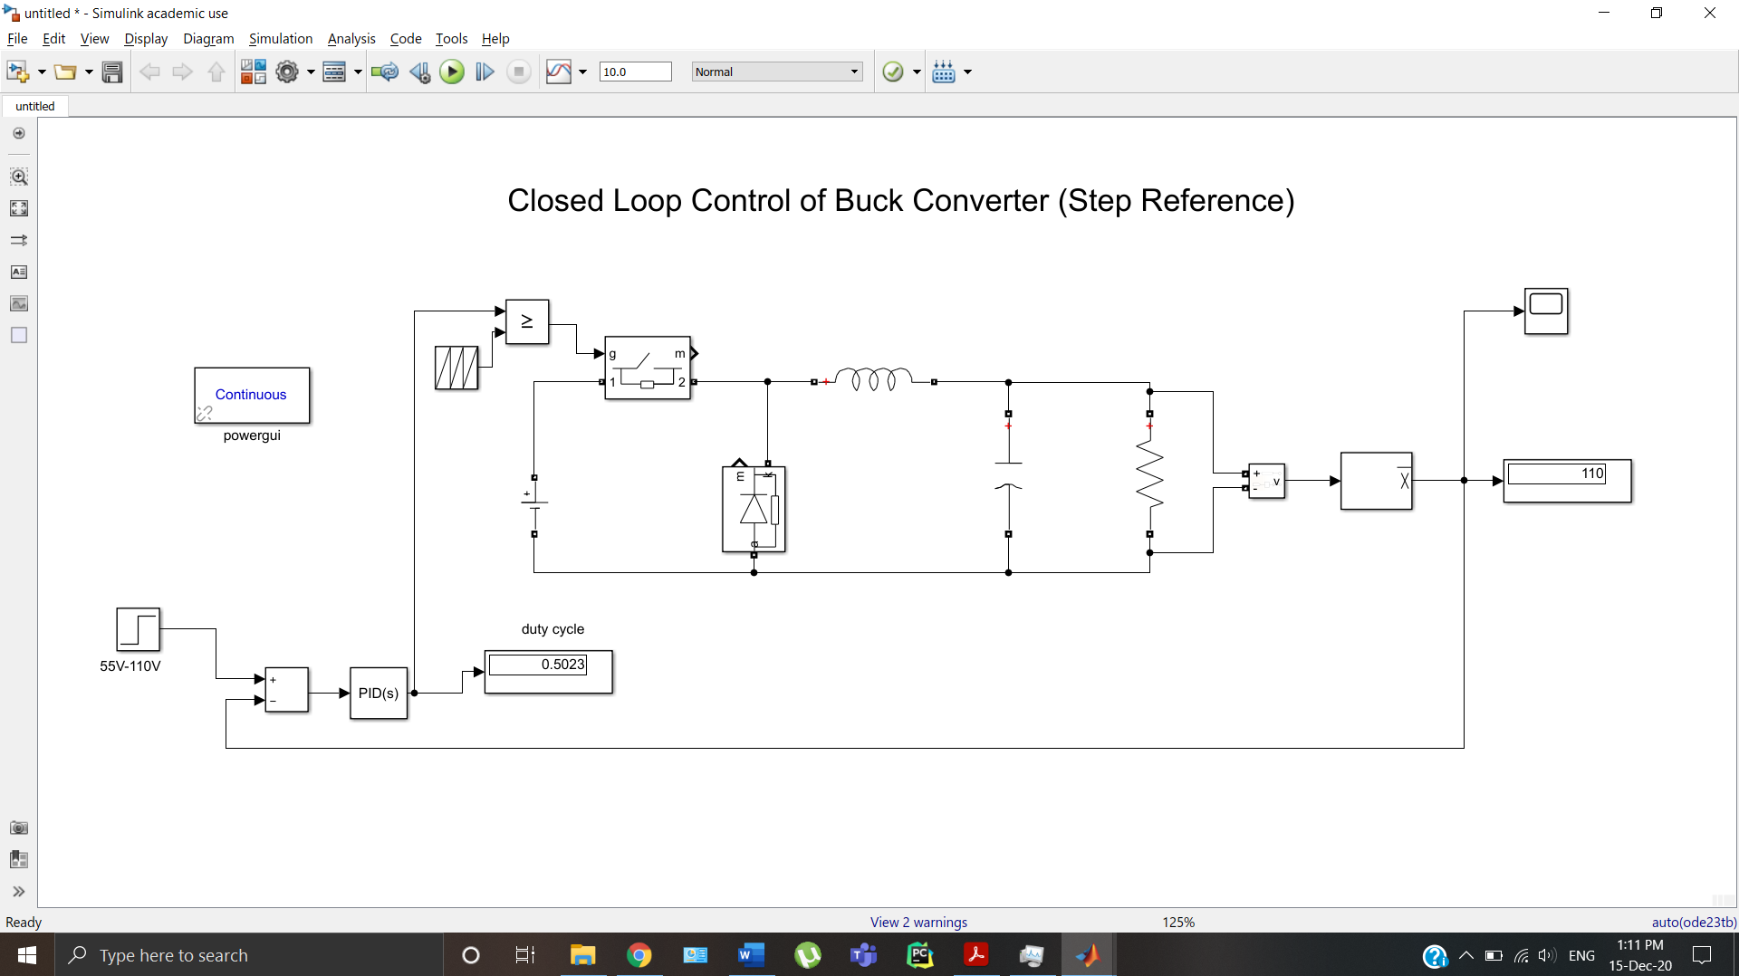

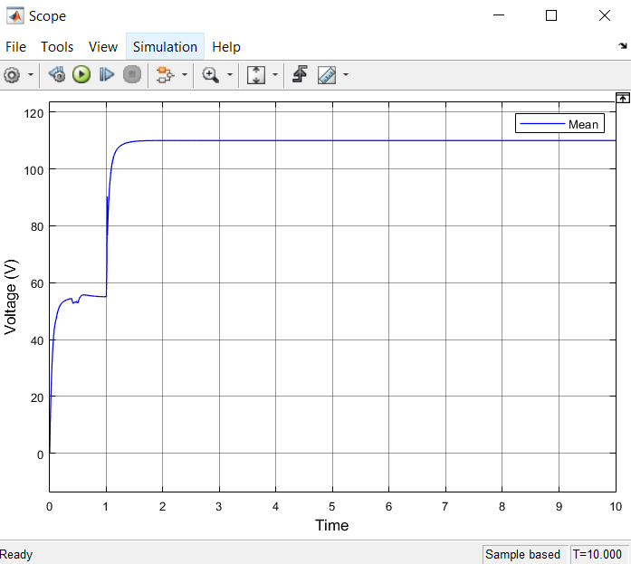

**Problem 2:**

Plot the voltage response of a closed loop Boost converter across a resistive load of 22 ohm. The source voltage is 220 V and PWM duty cycle is generated using PID controller block. Model the circuit with ideal switching devices and L = 100 ×10-3 H, C = 100 ×10-6 F and switching frequency 10KHz. Understand the significance of closed operation with a fixed reference point.

**SOLUTION:**

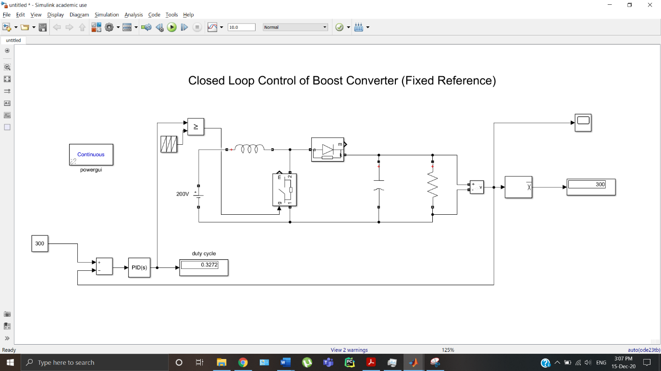

**kp=0.017, ki=0.08, kd=0**

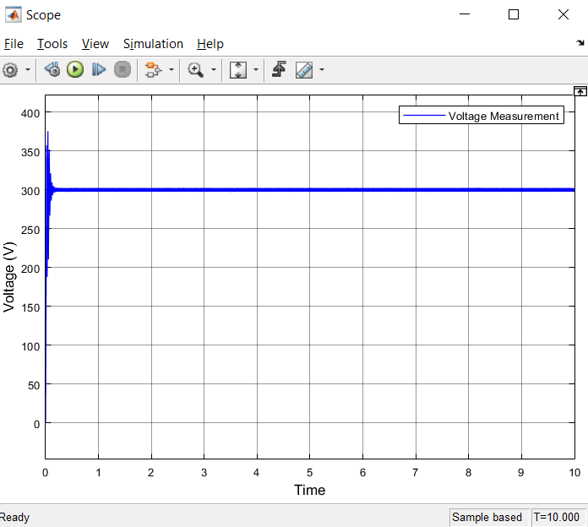

**Experiment IV:**

**Speed Response of a DC motor in Simulink and simscape**

**Aim:**

To model an armature controlled DC motor from first principles of modelling. Also simulate and analyze the motor performance as per specifications in SIMULINK.

**Problem 1:**

A Dc armature controlled motor with the following parameters: R = 2 Ω, L =1.1mH and Kb = 1.26 V/rad/sec, Kt = 1.26 N.m/Amp, with rotor parameters of J = 0.05kg-m2 **, B = 0 Nm/rad/sec** with no load is directly started from a dc supply voltage of 220V. Plot the motor starting speed response and the time taken to reach 157.07 rad/sec (1500 rpm).

**SOLUTION:**

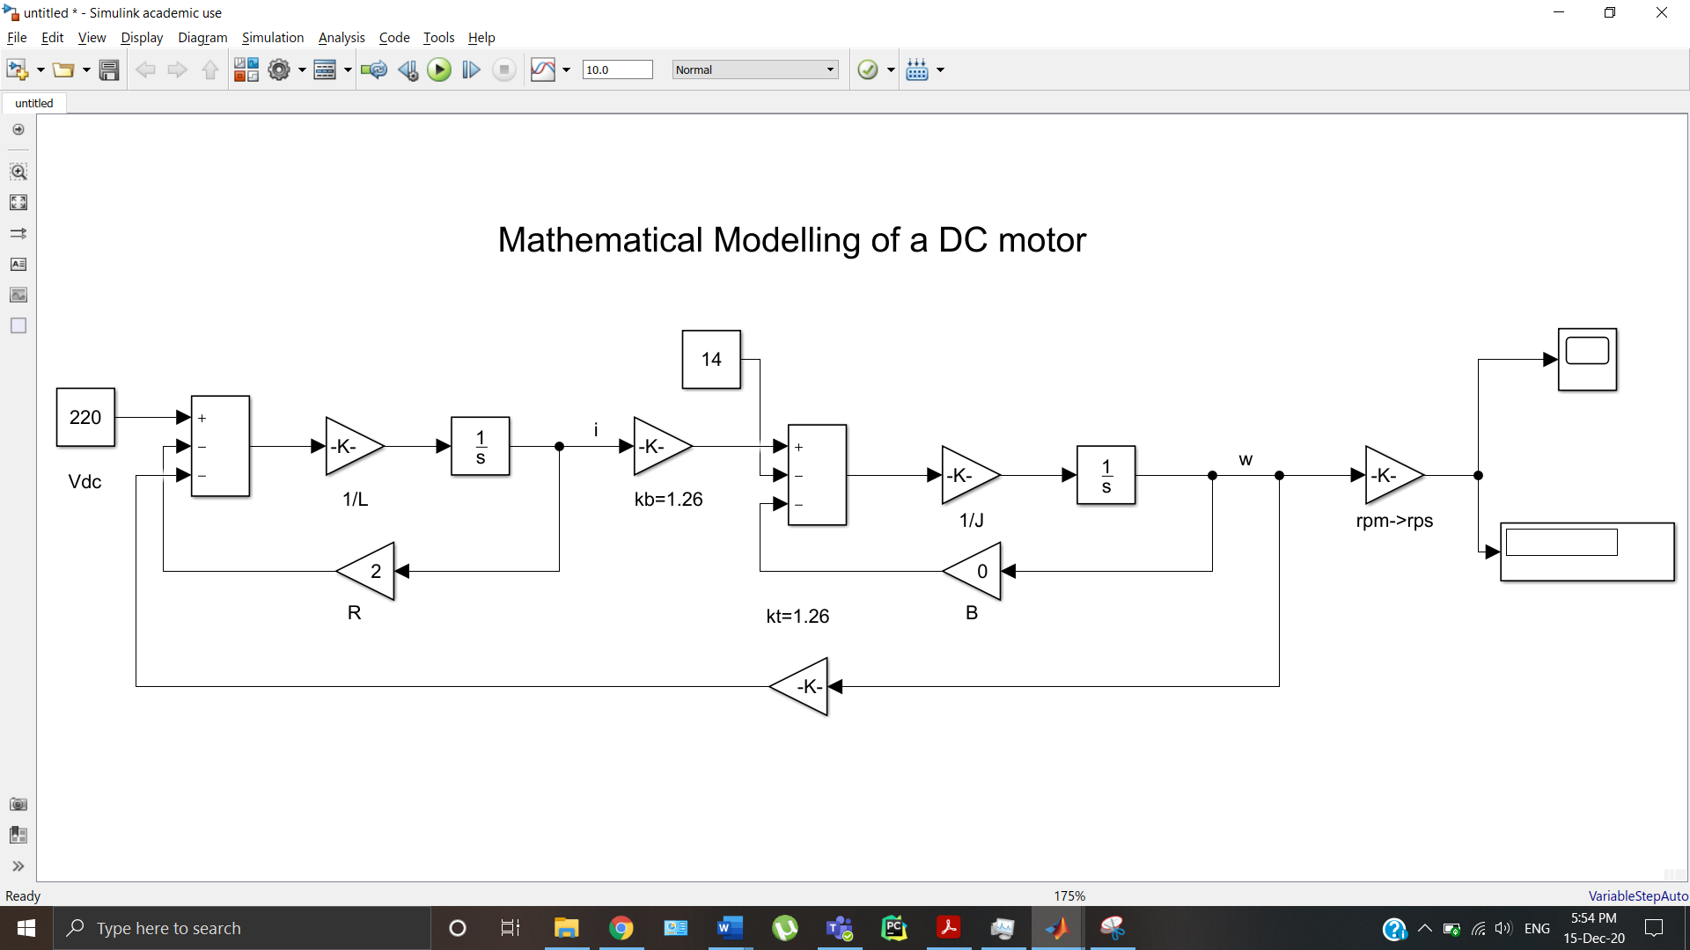

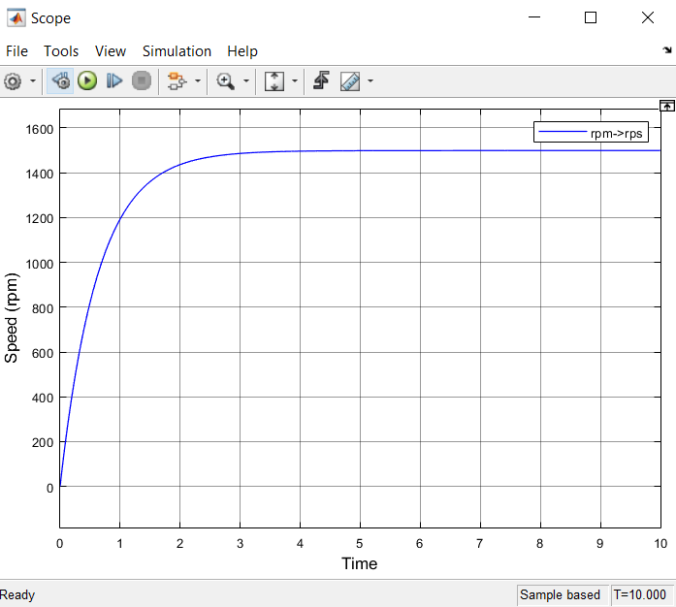

**Problem 2:**

A Dc armature controlled motor with the following parameters: R = 2 Ω, L =1.1mH and Kb = 1.26 V/rad/sec, Kt = 1.26 N.m/Amp, with rotor parameters of J = 0.05kg-m2 , B = 0 Nm/rad/sec with no load is directly started from a dc supply voltage of 220V and is given rated field current. Plot the motor starting speed response and the time taken to reach 157.07 rad/sec (1500 rpm) using simscape.

**SOLUTION:**

1. **Input voltage = 220V**

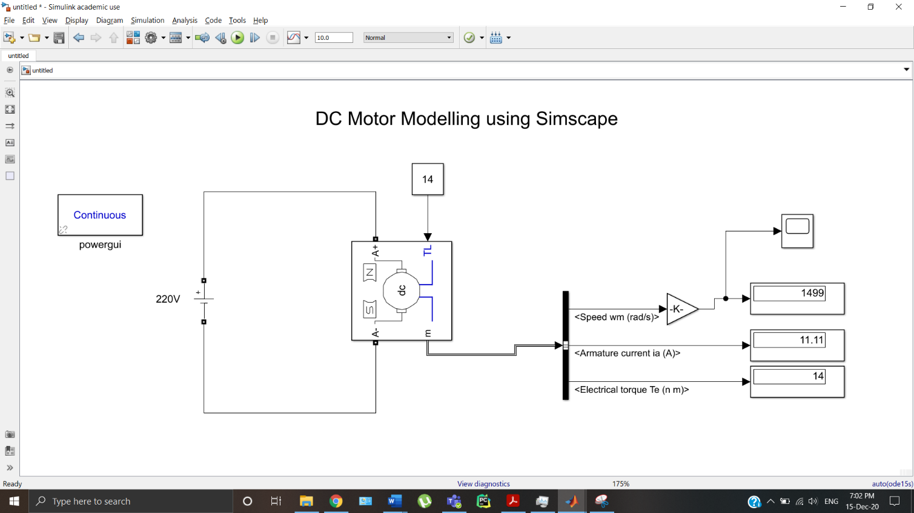

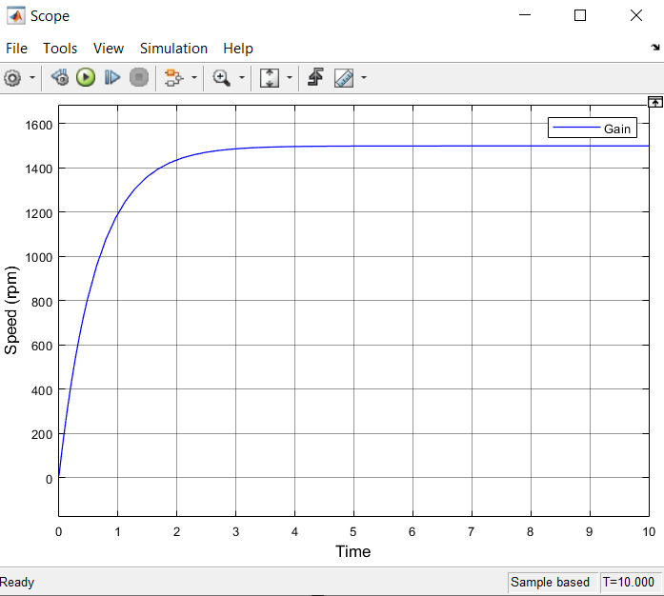

1. **Input voltage = 110V**

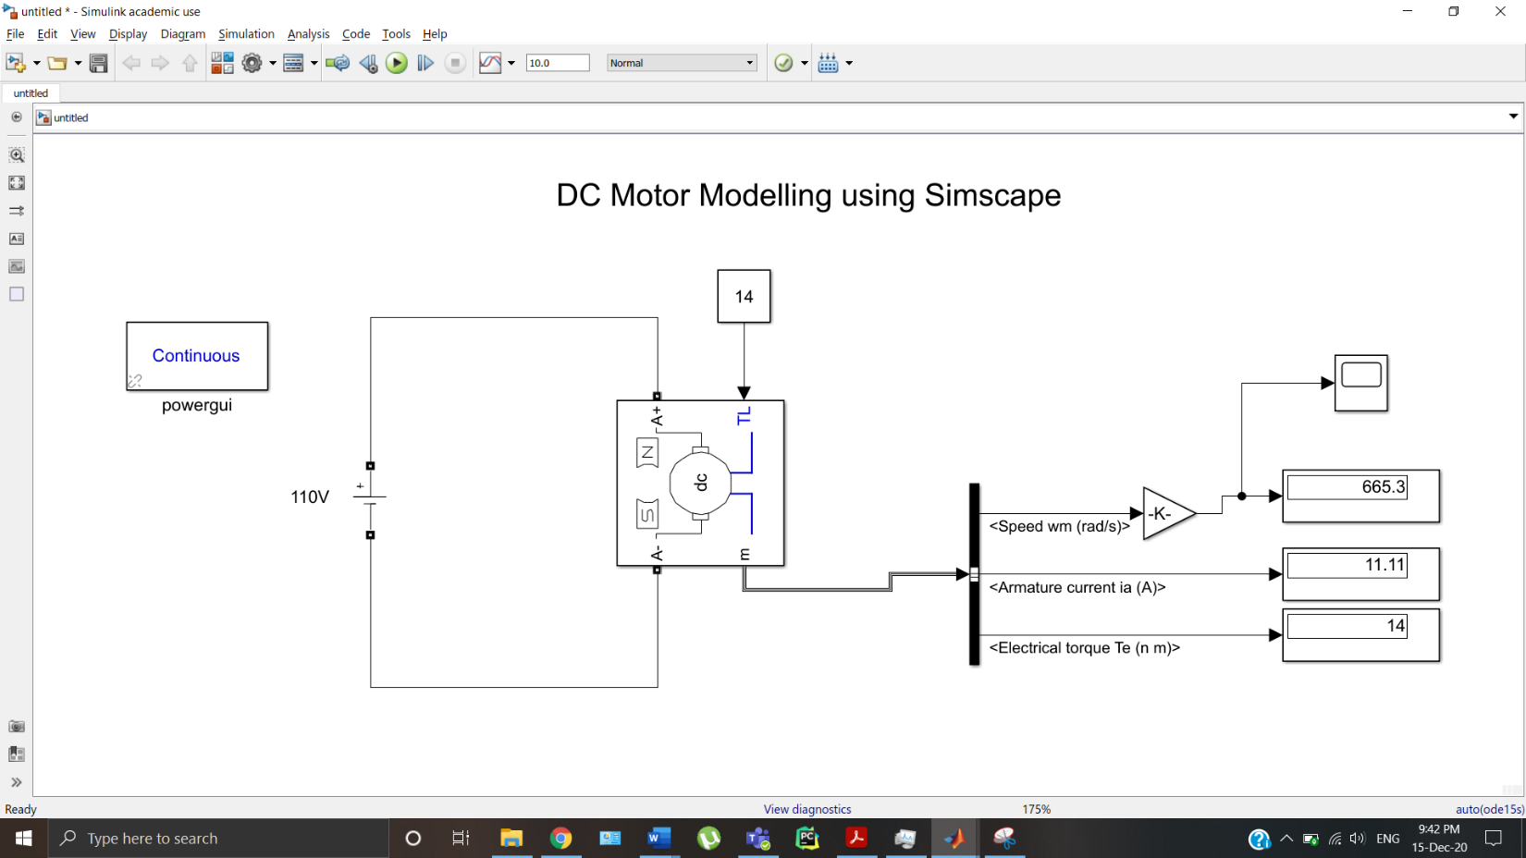

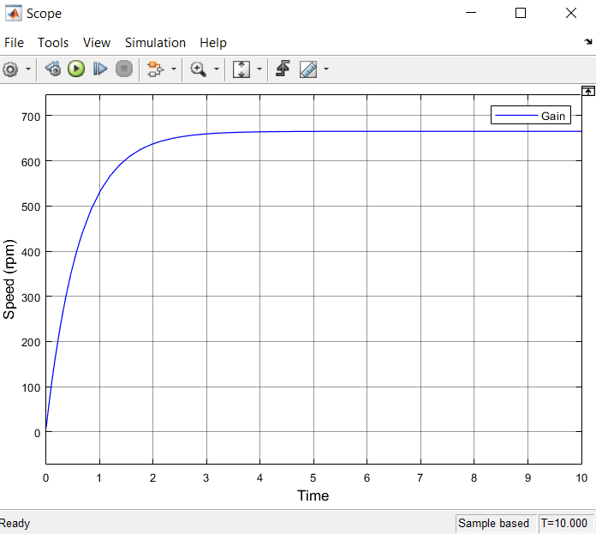

**Problem 3:**

A Dc armature controlled motor with the following parameters: R = 2Ω, L =0.011H and Kb = Kt 1.26V/rad/sec, with rotor parameters of J = 0.0167 kg-m2 , B = 0 Nm/rad/sec with a load torque is proportional to the speed of rotation, 𝑇𝐿=0.08 𝜔. Its armature is connected to a dc supply voltage of 220V and is given rated field current. Find speed of motor.

**SOLUTION:**

1. **Load torque**

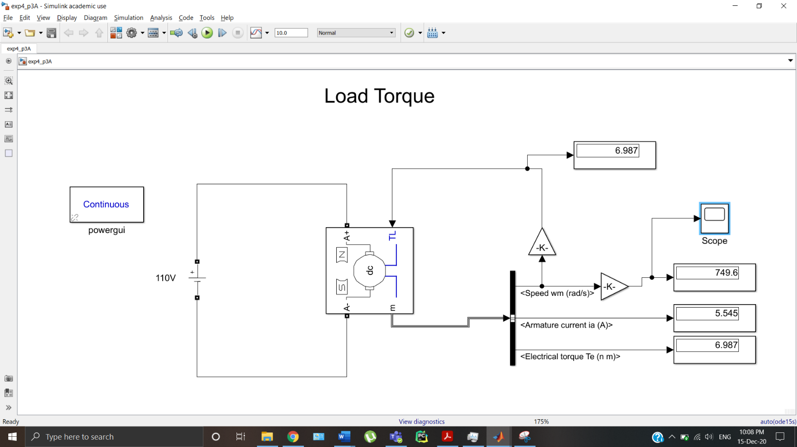

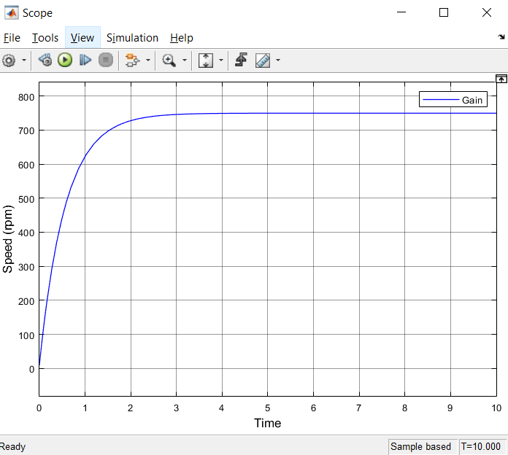

1. **Pump torque**

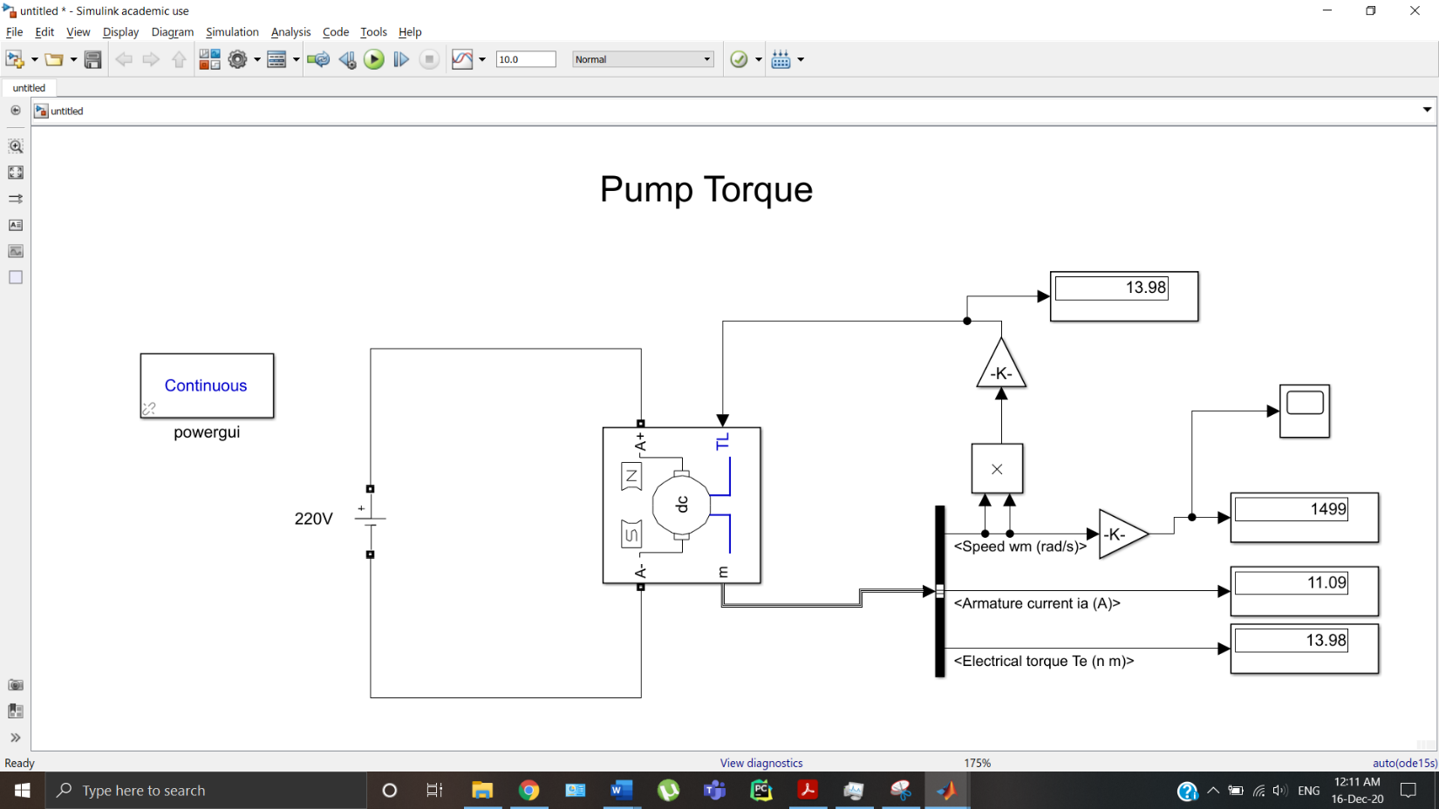

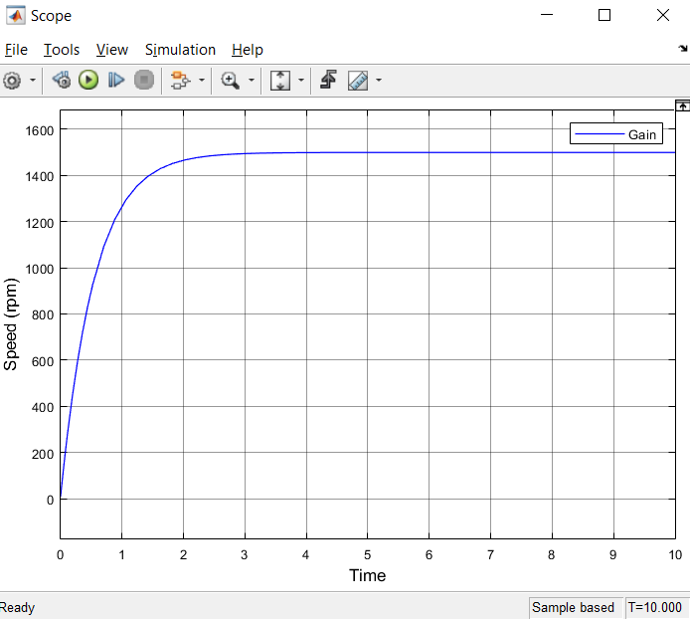

**Lab V:**

**Speed control of a DC motor using buck converter**

**Aim:** To model armature voltage speed control of DC motor using buck converter.

**Problem 1:**

A Dc armature controlled motor with the following parameters: R = 2 Ω, L =1.1mH and Kb = 1.26 V/rad/sec, Kt = 1.26 N.m/Amp, with rotor parameters of J = 0.05kg-m2 **, B = 0 Nm/rad/sec** with no load is directly started from a dc supply voltage of 220V. Plot the motor starting speed response and the time taken to reach 157.07 rad/sec (1500 rpm).

Control the speed of DC motor using armature voltage control through buck converter.

**SOLUTION:**

1. **Repeating Sequence**

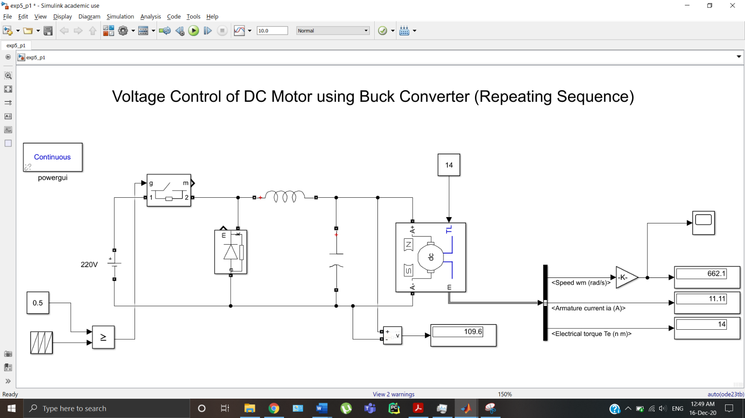

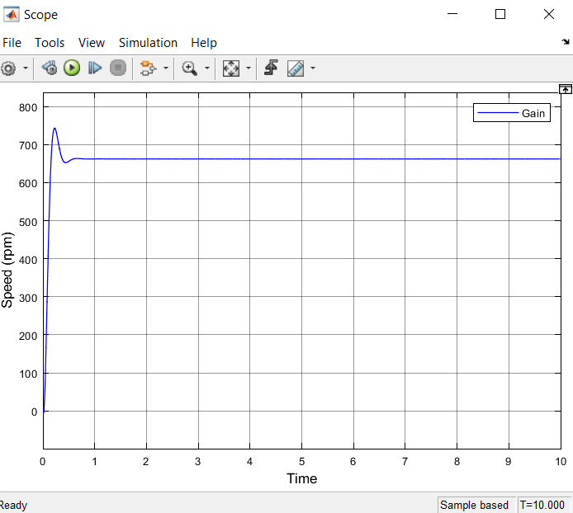

1. **PID Control**

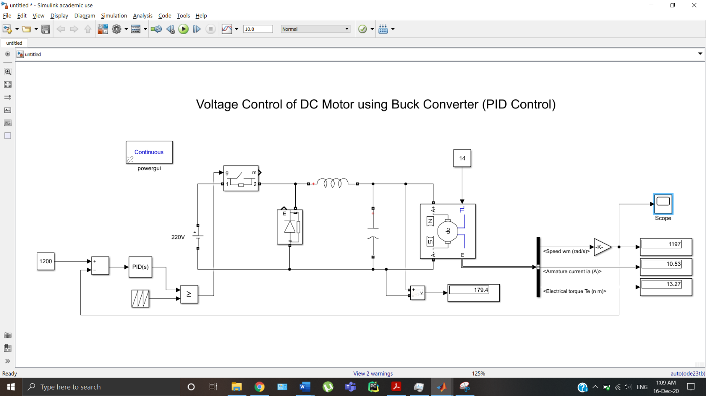

**Kp = 0.01, ki = 0.005, kd = 0.001**

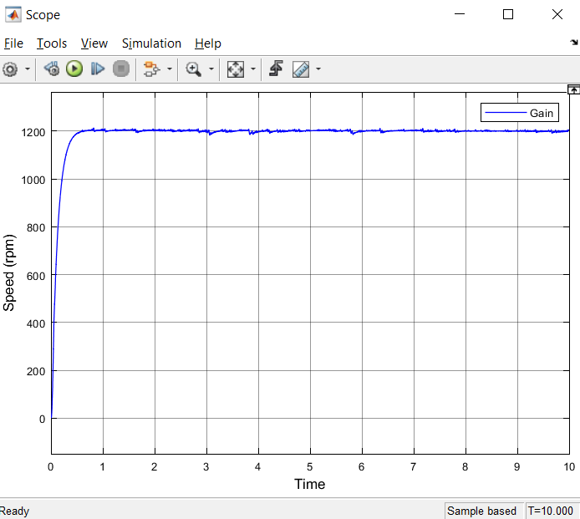

1. **PID Control – Step Input**

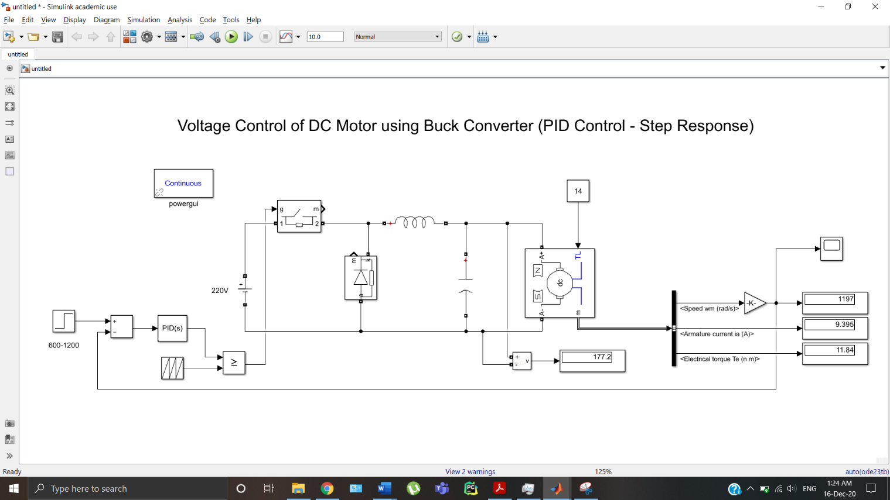

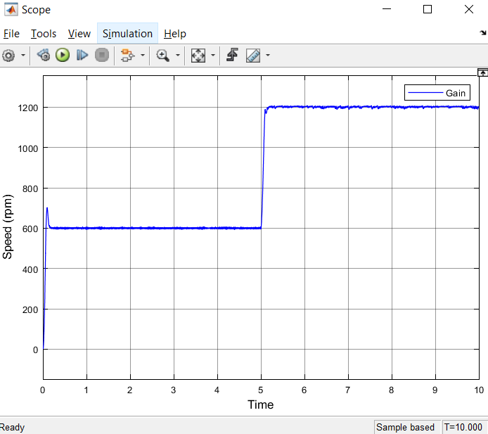

**Problem 2:**

To model and simulate the DC motor with closed loop speed control with current controller using Simscape. A Dc armature controlled motor with the following parameters: R = 1.1 Ω, L =0.003H and Kb = 1.2 V/rad/sec, Kt = 1.2 N.m/Amp, with rotor parameters of J = 0.05kg-m2 , B = 0.001 Nm/rad/sec. Develop the model and find the speed response with step change in speed and step change in load.

**SOLUTION:**

**Speed Controller:**

**Kp = 0.5, ki = 0.1, kd = 0**

**Current Controller:**

**Kp = 0.01, ki = 0.08, kd = 0**

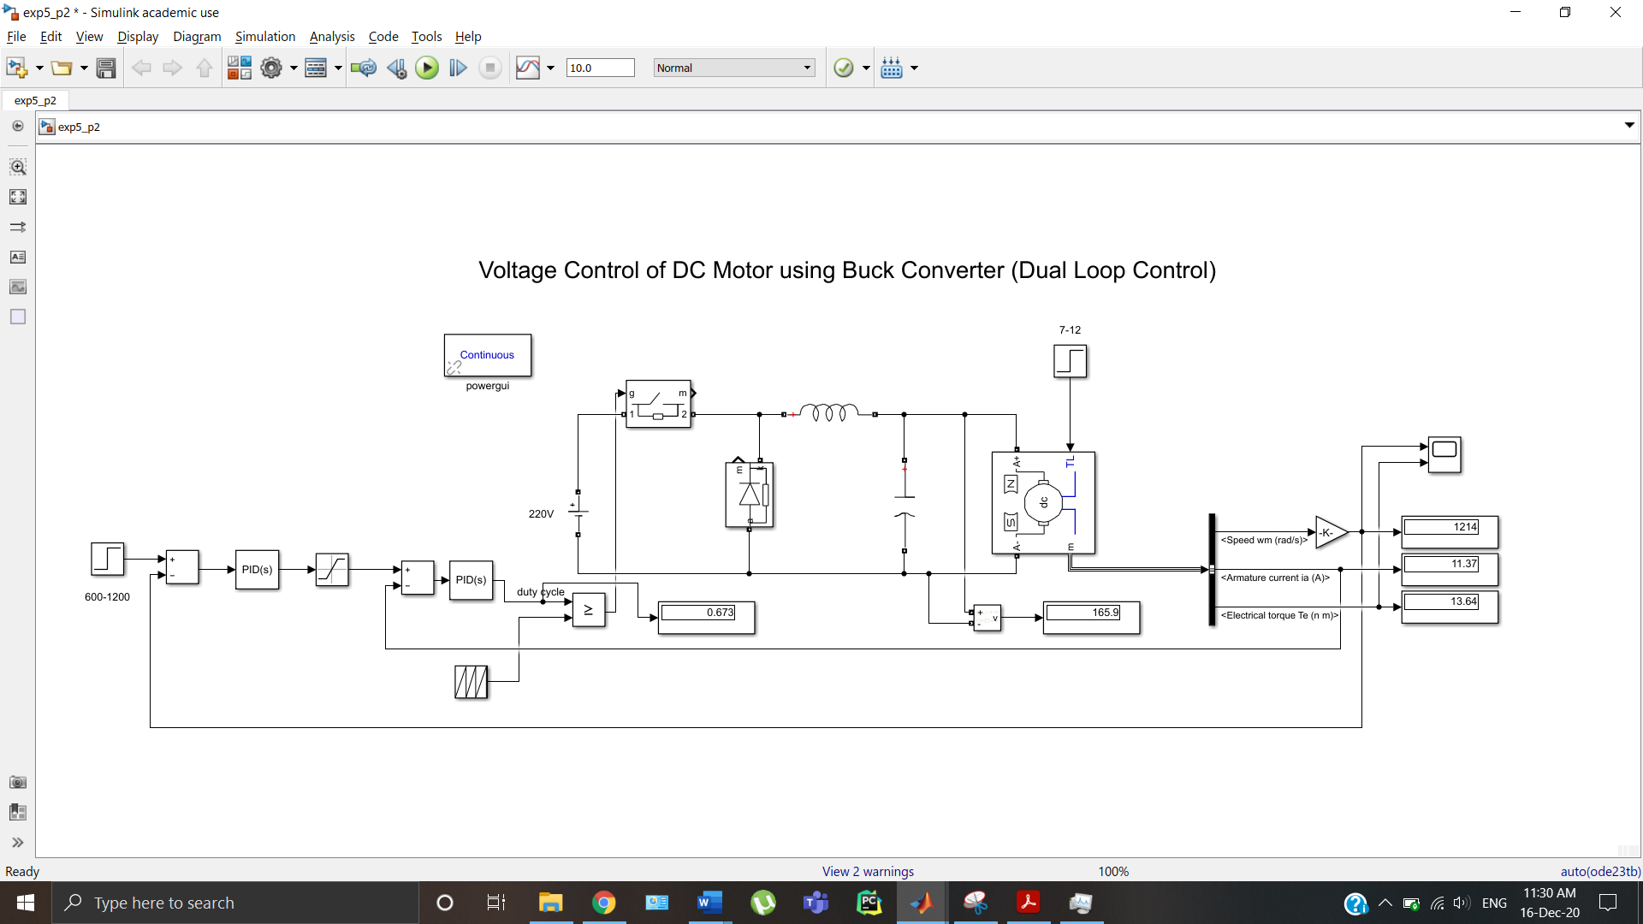

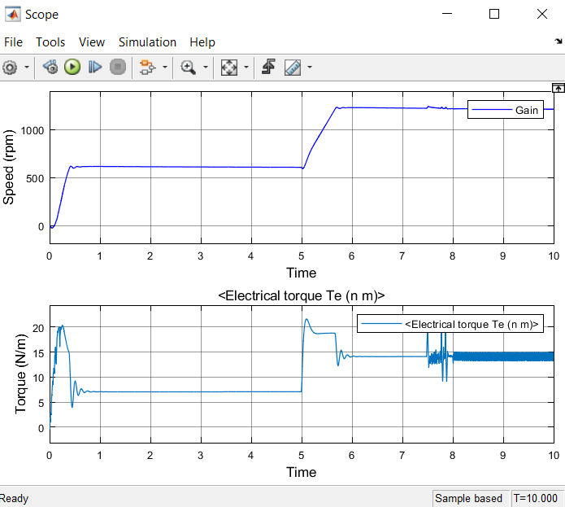

**Lab VI:**

**Modeling of single phase and three phase DC-AC Inverter using simscape**

**Aim:**

To familiarize with DC-AC converters and SPWM technique.

**Problem 1:**

To develop an single phase DC-AC inverter with DC voltage as 100 V and resistive load R=10 ohm. Observe the output Voltage to be AC form with 50Hz (0.02 sec). Observe the FFT analysis window of output voltage which depicts lower order harmonics (Which are hard to filter) Generate 100 Hz (0.01 sec) AC signal by adjusting pulse generators period.

**SOLUTION:**

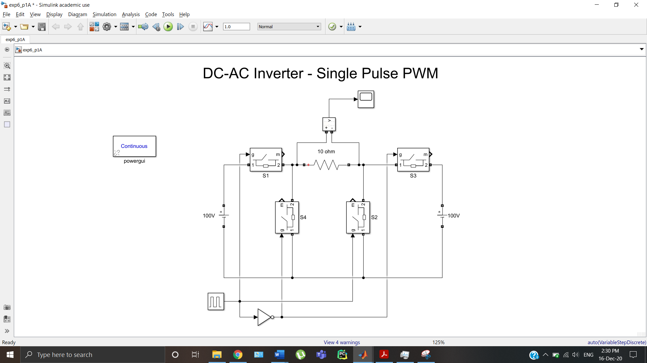

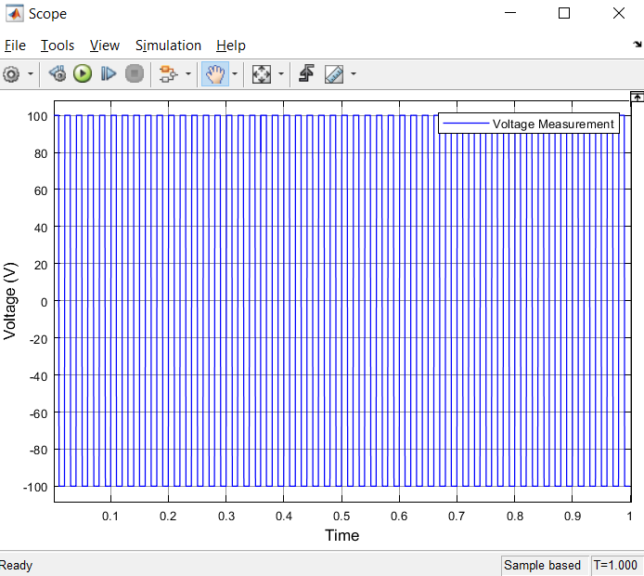

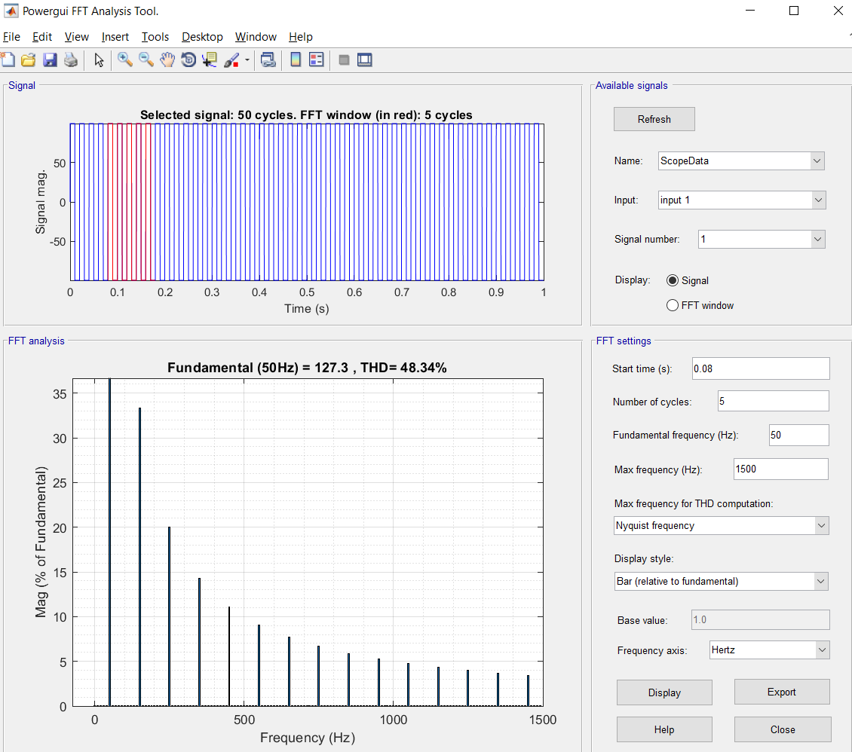

**Problem 2:**

To develop an single phase DC-AC inverter with DC voltage as 100 V and resistive load R=10 ohm using sine-PWM technique. Observe the output Voltage to be AC form with 50Hz (0.02 sec). The carrier frequency of triangular wave can be 1050 Hz. Observe the FFT analysis window of output voltage which depicts lower order harmonics (Which are hard to filter)

**SOLUTION:**

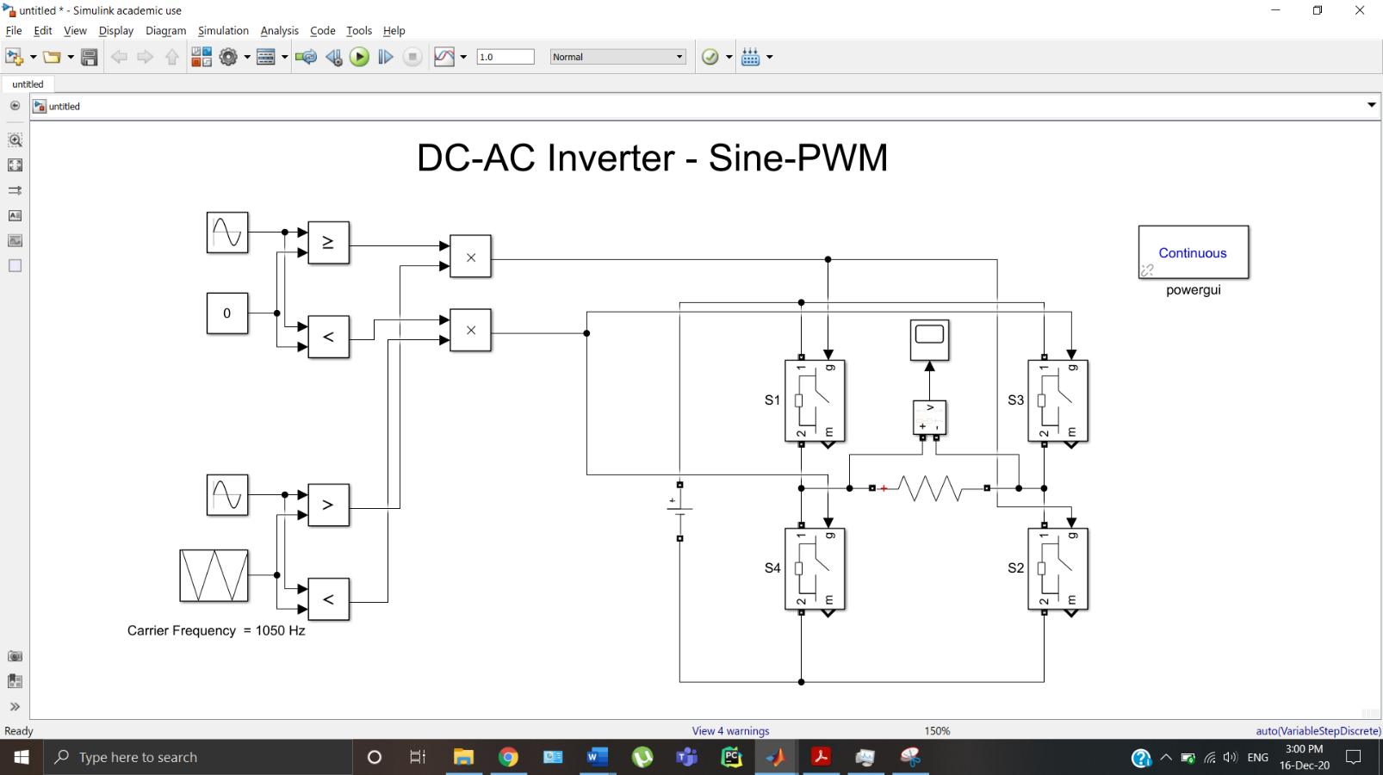

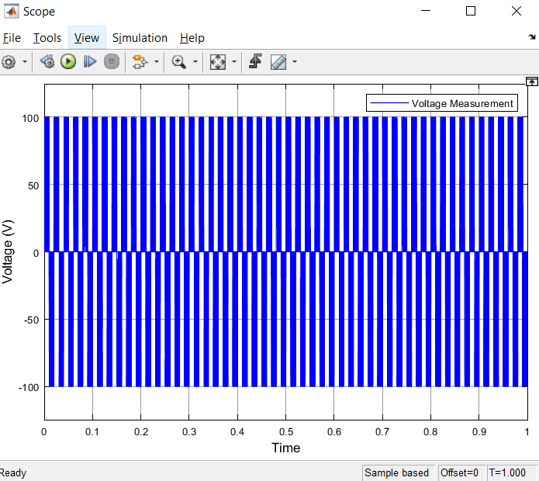

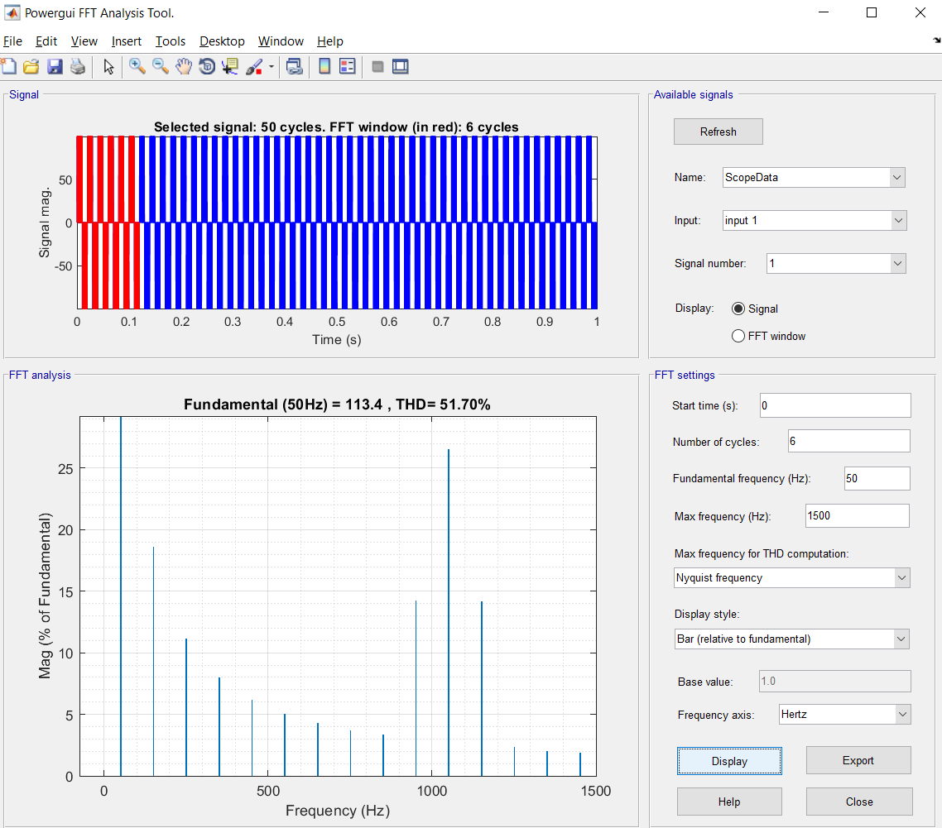

**Problem 3:**

Implement a three-phase inverter in 180° conduction mode

**SOLUTION:**

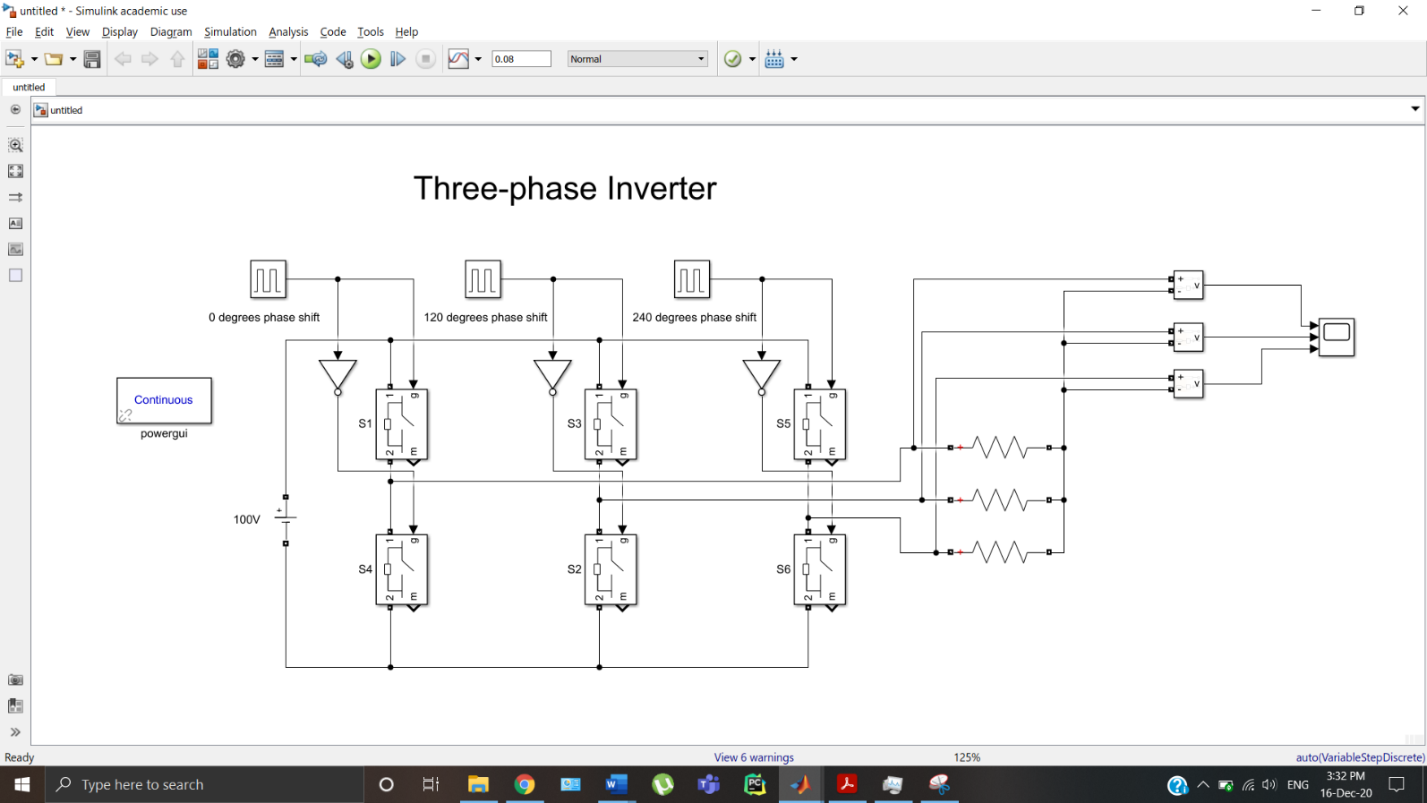

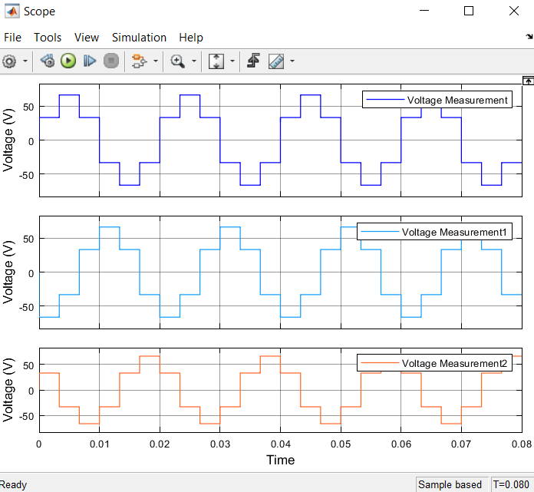

**Problem 4:**

Implement a three-phase inverter using an Asynchronous Machine in 180° conduction mode

**SOLUTION:**



